Autonomous RF Rover

Joseph DeLeonardis

Skylar Dolezal

Jacob Pantalone

Gabriel Wang

**Concept of Operations**

REVISION – Draft

November 28, 2018

Concept of Operations

for

Autonomous RF Rover

Team <1>

Approved by:

_____________________________

Project Leader Date

_____________________________

John Lusher, Ph.D, P.E. Date

_____________________________

T/A Date

**Change Record**

|  |  |  |  |  |
| --- | --- | --- | --- | --- |
| **Rev.** | **Date** | **Originator** | **Approvals** | **Description** |
| 1 | 02/19/2018 | Team 1 | Team 1 | Document created/Initial edit |
| 2 | 02/21/2018 | Team 1 | Team 1 | Draft Release |
| 3 | 11/28/2018 | Team 1 | Team 1 | Final Report |

1. **Table of Contents**

**Table of Contents III**

**List of Tables IV**

**List of Figures V**

**1.** **Executive Summary 1**

**2.** **Introduction 2**

2.1. Background 2

2.2. Overview 2

2.3. Referenced Documents and Standards 2

**3.** **Operating Concept 3**

3.1. Scope 3

3.2. Operational Description and Constraints 3

3.3. System Description 3

3.4. Modes of Operations 3

3.5. Users 3

3.6. Support 3

**4.** **Scenario(s) 4**

4.1. Scenario Name #1 4

**5.** **Analysis 4**

5.1. Summary of Proposed Improvements 4

5.2. Disadvantages and Limitations 4

5.3. Alternatives 4

**List of Tables**

No table of figures entries found.

**List of Figures**

Figure 1. Project Overview………………...………………………………………………….1

# Executive Summary

This project consists of four subsystems that will combine to function as an autonomous RF Rover that will be able to estimate its location in a building. The rover will have an antenna that will be able to intercept wifi signals that will convert to data. This will then be communicated to a server, where the data will be analyzed by a KNN MLA to determine its location. This signal will then be sent back to the rover so that it will know its location and be able to adjust accordingly. The end goal will be to have the RF rover move down the hall and stop correctly at a designated position using RF.

# Introduction

This RF Rover project was introduced by Dr. Huff and his research lab to our senior design group in class ECEN 403. Many of the principles involved in this project have been shown to be possible with past projects/research. However, these principles have not been applied in the manner in which we intend to use them. The successful integration of using RF and a machine learning algorithm for the rover to identify its location will indicate that the technology can be used and eventually expanded to applications such as a phone app to assist the visually impaired with determining their location in a building.

## 2.1 Background

With increasing research in the field of RF, electromagnetics, and machine learning, it is becoming more possible to utilize these fields in applications such as location identification inside a building. These technologies can be applied to applications such as ours that can be eventually used to aid the visually impaired.

There isn’t a current RF tracking system on the market for inside a building. The closest system that exists on the market today is GPS (Global Positioning System), that allows users to track location with up to a 3 meter accuracy. This is typically used outdoors to go from location to location. Our system will be used for inside building and have a greater accuracy in order to identify locations as specific as rooms.

## 2.2 Overview

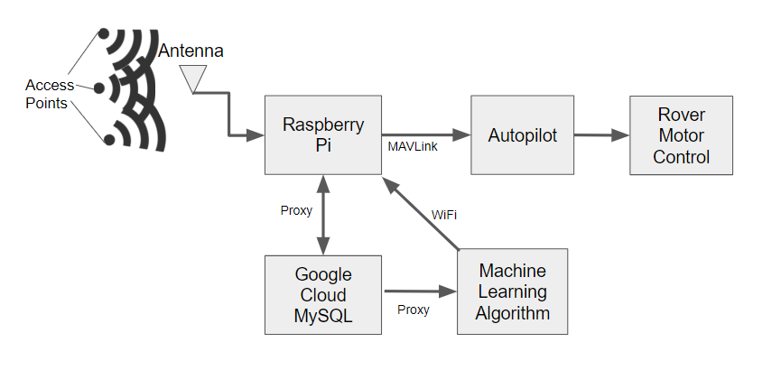

Figure 1: Project Overview

The RF mapping rover will receive RSSI signals from four designated WiFi base stations while navigating a straight path. These signals will be received in both 2.4GHz and 5.8GHz. This data will be stored in a CSV database and analyzed by a MLA. The MLA will the send back information to a RPI about the rover’s position in the hallway. The RPI will use this information to send control and maneuver commands via MAVLink protocol to the autopilot until the rover gets to its destination. The information transfer, position updates, and control commands will be nearly continuous while the rover is on its path.

## 2.3 Referenced Documents and Standards

**[1]** IEEE 802.11 is a set of media access control (MAC) and physical layer (PHY) specifications for implementing wireless local area network (WLAN) computer communication in the 900 MHz and 2.4, 3.6, 5, and 60 GHz frequency bands.

**[2]** Arudpilot.org.(2016). Communicating with Raspberry PI via MAVLink - Dev documentation. [online] Available at: http://ardupilot.org/dev/docs/raspberry-pi-via-mavlink.html

**[3]** scikit-learn: machine learning in Python — scikit-learn 0.19.1 documentation", *Scikit-learn.org*, 2018. [Online]. Available: http://scikit-learn.org/stable/

**[4]** Data School", *Data School*, 2018. [Online]. Available: http://www.dataschool.io/

**[5]** Python.dronekit.io. (2015). *DroneKit-Python API Reference*. [online] Available at: http://python.dronekit.io/automodule.html

# Operating Concept

## 3.1 Scope

The testing of the RF rover will be confined to one hallway, where the rover will stop in front of specified locations in front of doors on either side of the hallway. Each specified location will have a unique wifi footprint determined from wifi access point addresses and their respective Received Signal Strength Indicator (RSSI) values. The rover will be able to identify the specified locations by first collecting Wifi signals via 2.4/5 GHz antenna connected to a RPI microcontroller using Wireshark software, a network protocol analyzer. Once Wifi data has been collected, the RPI will send the data to a MySQL database hosted on the Google Cloud Platform. A MLA will then determine whether the rover is in specified location based on collected data and the location Wifi footprint within a certain confidence range. Once algorithm determine whether rover is in location, a command to either stop or continue will communicated to the rover control over a MAVProxy server using MAVLink Protocol.

## 3.2 Operational Description and Constraints

## 3.3 System Description

**RF**The RF subsystem will utilize a dual band 2.4 / 5.8 GHz antenna connected to a RPI utilizing the linux operating system to grab useful signals from nearby wireless base stations including RSSI data and IP addresses. Utilizing wireshark, these signals are collected and saved to be sent to our database in order to be accessed by the MLA and create a working dataset. Once a working MLA is created, the system will work in real time to be able to grab data, send it to the database, run through the MLA, then receive a command of whether or not it is in the right location.

**2.4 GHz Directional Antenna:** This antenna utilizing monitor mode will grab data including IP addresses and RSSI signals.

**Raspberry PI 3:** The RP3 microprocessor will interface with the antenna and the rover to control and issue commands.

**Feather Huzzah ESP8266:** The Feather Huzzah will serve as a wireless access point. It will output 2.4 GHz signals that the antenna will collect.

**Vehicle**The vehicle subsystem utilizes a RPI, Pixhawk module, and dual band antenna. The RPI receives commands from the MLA in the database and then communicates through a MAVProxy server to the Pixhawk. The communication over the server between the RPI and the Pixhawk is done using MAVLink protocol to address the different components and motors connected to the Pixhawk. The program running on the RPI uses the information sent from the MLA to determine how the rover will move relative to its current position.

**DataBase**

A MySQL database managed in the cloud, hosted on Google Cloud SQL, will collected data from the RP3 through a Proxy. The MySQL database will be a relational data stream management system that stores the different Wifi Access point’s addresses, their corresponding RSSI values, and the sequence the of their transmission. The collected data will available to analyze by MLA through it’s own Proxy.

**Machine Learning**The MLA will be trained from a training dataset that is stored on an CSV database and managed on the pi. While the antenna is collecting data, that data will passed through the MLA so that the rover can make predictions on where to drive based on the previous collected data. This testing will then be stored in a CSV so that the KNN MLA can run and output a predicted position. Several tests will be done prior to the final to validate an accuracy of 80% of more.

**3.4 Modes of Operations**

The rover will store RSSI data to an CSV file, which will then be compared with a training data set by a MLA. The predicted relative position information will be sent back to the rover so that it can make a decision on which direction to drive to reach the desired location.

**3.5 Users**

The rover will be a proof of concept that supervised MLAs can use RSSI data to determine relative position within a building. This application could be used to assist visually impaired people navigate buildings.

## 3.6 Support

User manuals will be provided with detailed block diagrams of how the rover is sending and receiving data and an a description of how the MLA works. This will allow users to troubleshoot any issues that arise if difficulty occurs after project completion.

# Scenario

## 4.1 Autonomous rover driving

We will demonstrate the rover’s ability to maneuver by starting the rover at a designated position, having it drive down a straight line, and making it stop at destination preset by the user to demonstrate the rover’s ability to move forward, backward, or stop.

# Analysis

## 5.1 Summary of Proposed Improvements

* Develop an application for mobile devices that utilizes data from the autonomous radio frequency mapping rover to help visually impaired people navigate indoors.

## 5.2 Disadvantages and Limitations

The RF mapping rover will have some limitations which include:

* The rover shall only collect data sets at a designated time of the day for testing and lack the ability to retain enough data points to eliminate all the interference in-doors from other wifi base stations.
* Data will be only collected in the x direction which will only allow the rover to drive with a KNN algorithm instead of being able to test other methods.

## 5.3 Alternatives

An alternate solution would be to try to use other signals at different frequencies such as using bluetooth. However this signal is not as commonly found in buildings and the signal would not be as strong.

Autonomous RF Rover

Joseph DeLeonardis

Skylar Dolezal

Jacob Pantalone

Gabriel Wang

**Functional System Requirements**

**subsystem if needed**

REVISION – Draft

December 5, 2018

Functional System Requirements

for

Autonomous RF Rover

Prepared by:

_____________________________

Author Date

Approved by:

_____________________________

Project Leader Date

_____________________________

John Lusher, Ph.D, P.E. Date

_____________________________

T/A Date

**Change Record**

|  |  |  |  |  |
| --- | --- | --- | --- | --- |
| **Rev.** | **Date** | **Originator** | **Approvals** | **Description** |
| **-** | 02/19/2018 | Team 1 | Team 1 | Document created/Initial edit |
| **-** | 02/21/2018 | Team 1 | Team 1 | Draft Release |
| **-** | 12/05/2018 | Team 1 | Team 1 | Final Copy |

**Table of Contents**

**Table of Contents. II**

**List of Tables. IV**

**No table of figures entries found. IV**

**List of Figures. V**

**1. Introduction. 1**

1.1. Purpose and Scope. 1

1.2. Responsibility and Change Authority. 1

**2. Applicable and Reference Documents. 2**

2.1. Applicable Documents. 2

2.2. Reference Documents. 2

2.3. Order of Precedence. 3

**3. Requirements. 4**

3.1. System Definition. 4

3.2. Characteristics. 4

3.2.1. Functional / Performance Requirements. 4

3.2.2. Physical Characteristics. 5

3.2.3. Electrical Characteristics. 6

3.2.4. Environmental Requirements. 8

3.2.5. Failure Propagation. 9

**4. Support Requirements. 10**

**Appendix A Acronyms and Abbreviations. 11**

**Appendix B Definition of Terms. 12**

**Appendix C Interface Control Documents. 12**

**List of Tables**

Table 1. Subsystem Responsibilities…………………………………………………………………..1

Table 2. Applicable Documents………………………………………………………………………...2

Table 3. Reference Documents………………………………………………………………………...2

**List of Figures**

Figure 1. Project Conceptual Image…………………………….………………………….1

Figure 2. Block Diagram of System………………………………………………………...4

# 1. Introduction

## 1.1. Purpose and Scope

To develop a system of indoor navigation of a building. Rather than using traditional methods of navigating through a building, our aim is to provide a means of relative position detection based on WiFi signal strength data. Our RF mapping rover will drive down a hallway in the Wisenbaker building, collect data, export to a database, utilize a KNN MLA to decipher the raw data and determine its assumed position, and communicate to a RPI to move the rover based on the assumed position. The system shall denote it’s median predicted position as its location and have a 80% confidence interval between the training and testing dataset.

## 1.2. Responsibility and Change Authority

All changes to the system shall be discussed and approved amongst the entire group at weekly meetings, with the guidance of Dr. Huff.

|  |  |  |
| --- | --- | --- |
| **Team Member** | **Subsystem** | **Responsibility** |
| Jacob Pantalone | Vehicle | Communicating to the existing autopilot program to control rover and exporting data. |
| Gabriel Wang | RF | Intercept WIFI base station signals with an antenna and filter out useful data to be sent to the database. |
| Skylar Dolezal | Database | Assemble a MySQL database via the Google Cloud API that will receive and organize transmitted data. |
| Joseph DeLeonardis | Machine Learning | Import the testing set into a KNN MLA that will compare with a predefined training set to compute where the rover needs to drive. |

Table 1: Subsystem Responsibilities

# 2. Applicable and Reference Documents

## 2.1. Applicable Documents

The following documents, of the exact issue and revision shown, form a part of this specification to the extent specified herein:

|  |  |  |
| --- | --- | --- |
| **Document Number** | **Revision/Release Date** | **Document Title** |
| IEEE 802.11 | 2016 | IEEE Standard for information Technology |

Table 2: Applicable Documents

## 2.2. Reference Documents

The following documents are reference documents utilized in the development of this specification. These documents do not form a part of this specification and are not controlled by their reference herein.

|  |  |  |
| --- | --- | --- |
| **Document Number** | **Revision/Release Date** | **Document Title** |
| Version 1.4 | MAY 2017 | SDI-12 A Serial-Digital Interface Standard For Microprocessor-Based Sensors |

Table 3: Reference Documents

## 2.3. Order of Precedence

In the event of a conflict between the text of this specification and an applicable document cited herein, the text of this specification takes precedence without any exceptions.All specifications, standards, exhibits, drawings or other documents that are invoked as “applicable” in this specification are incorporated as cited. All documents that are referred to within an applicable report are considered to be for guidance and information only, except ICDs that have their relevant documents considered to be incorporated as cited.

**3. Requirements**

## 3.1. System Definition

The Autonomous RF Rover is a reliable proof of concept for using a KNN MLA to predict the relative location within a building using the RSSI data provided from the wifi base stations. The Autonomous RF Rover has four subsystems: Machine learning, Database, Antenna and Vehicle.



Figure 1: System Block Diagram

There will be a previously collected set of data called a training dataset that is already stored on the pi with a KNN MLA trained to that dataset. Then an antenna subsystem will use used to intercept the RSSI data from the designated wifi base stations. The KNN MLA will be able to make predictions on the data that is collected based on relationship between the previous collected data and the relative position. Lastly, the vehicle subsystem will programmed to drive in the direction of the indicated by the testing data.

## 3.2. Characteristics

### 3.2.1. Functional / Performance Requirements

#### **3.2.1.1. Confidence interval**

The minimum percent accuracy between the training and testing dataset algorithm shall be above 80%.

Rationale: This will ensure that the system is working and that there can be a practical use for this in future applications.

#### **3.2.1.2. Captured data points**

The system using Wireshark software should capture at least 100,000 data points to run through the machine learning algorithm.

Rationale: This will allow the algorithm to be able to accurately predict where its location is.

### 3.2.2. Physical Characteristics

#### **3.2.2.1. System Operating Area**

The system shall operate effectively in at least one length of hallway or linear space outside.

Rationale: This will provide a proof of concept that RSSI data can be used to determine a relative position.

### 3.2.3. Electrical Characteristics

#### **3.2.3.1. Inputs**

The system will have a radio input and a antenna.

Rationale: This will ensure that the rover can send and receive data.

##### 3.2.3.1.1 Power Consumption

The maximum peak power of the system shall not exceed 504 watts.

Rationale: The IG42 24VDC 122 RPM Gear Motor has a rated voltage of 24VDC and a  
 rated current of 2100mA.

##### 3.2.3.1.2 Input Voltage Level

The input voltage level for RPI will be 5.1VDC

Rationale: The RPI will need 5.1V to adequately power the microprocessor.

The input voltage level for the motor control will be 12VDC

Rationale: The motors will be supplied with 12 volts so that we are able to reach the  
 desired rated torque of 700g-cm and speed of 5700rpm

##### 3.2.3.1.3 External Commands

The MLA shall document all external commands in the appropriate ICD.

Rationale: The ICD will capture all interface details from the low level electrical to the high-level packet format.

#### **3.2.3.2. Outputs**

##### 3.2.3.2.1 Data Output

The Autonomous RF Rover shall output the testing data collected from into a CSV file repository so that the percent error can be computed by comparing it to the training set.

#### **3.2.3.3. Wiring**

The Autonomous RF Rover shall follow the guidelines outlined in MIL-HDBK-5400 paragraph 4.3.35 Wire and cable.

### 3.2.4. Environmental Requirements

The Autonomous RF Rover shall be designed to withstand and operate in the environments and laboratory tests specified in the following section.

### 3.2.5. Failure Propagation

#### **3.2.5.1. Failure Detection, Isolation, and Recovery (FDIR)**

The Autonomous RF Rover may have a method of eliminating signal noise. Several data sets of data are going to have to be collected to determine if this may prevent the system from having a good confidence interval.

**3.2.5.1.1 Built In Test (BIT)**

The rover may be attached with indoor navigation beacon that can determine absolute position. This position can be compared to desired position and determine test failure or success.

**3.2.5.1.1.2 Noise Detection**

The rover may be required to account for signal noise to achieve the specified confidence interval.

**3.2.5.1.1. Position Log**

The rover shall save the results of each test to a csv file to compare to a training dataset

# 4. Support Requirements

The purpose of this project is to prove a theory is possible as opposed to a final product that would be used by a customer.

# Appendix A: Acronyms and Abbreviations

Below is a list of common acronyms and abbreviations, update based upon your project….

GHz Gigahertz (1,000,000,000 Hz)

Hz Hertz

ICD Interface Control Document

kHz Kilohertz (1,000 Hz)

mA Milliamp

MLA Machine Learning Algorithm

MTBF Mean Time Between Failure

MTTR Mean Time To Repair

RF Radio Frequency

RPI Raspberry Pi

RSSI Relative Signal Strength Indicator

SQL Structured Query Language

TBD To Be Determined

WIFI Wireless Fidelity

KNN K-Nearest Neighbors

CSV Comma Separated Values

# 

# 

# 

# Appendix B: Definition of Terms

Monitor Mode Allows a computer with a wireless network interface controller  
 to monitor all traffic received from the wireless network

Proxy A server that will pass information from RPI to Google Cloud SQL

instance, bypassing IP address blocking.

Tshark Terminal oriented version of Wireshark designed for capturing and   
 displaying packets when an interactive user interface isn't necessary or   
 available.

Wireshark Open source packet analyzer that is used for network troubleshooting and   
 analysis.

Wifi Base Station The device that outputs wifi data such as the IP address and RSSI.

# 

# 

Autonomous RF Rover

Joseph DeLeonardis

Skylar Dolezal

Jacob Pantalone

Gabriel Wang

**Interface Control Document**

**subsystem if needed**

REVISION – Draft

December 5, 2018

Interface Control Document

for

Autonomous RF Rover

Prepared by:

_____________________________

Author Date

Approved by:

_____________________________

Project Leader Date

_____________________________

John Lusher, Ph.D, P.E. Date

_____________________________

T/A Date

**Change Record**

|  |  |  |  |  |
| --- | --- | --- | --- | --- |
| **Rev.** | **Date** | **Originator** | **Approvals** | **Description** |
| **-** | 02/19/2018 | Team 1 | Team 1 | Document created/Initial edit |
| **-** | 02/21/2018 | Team 1 | Team 1 | Draft Release |

**Table of Contents**

**Table of Contents**. III

**List of Tables.** IV

**List of Figures.** V

**1. Executive Summary**. 1

**2. Introduction**. 2

2.1. Background. 2

2.2. Overview.. 2

2.3. Referenced Documents and Standards. 2

**3. Operating Concept** 3

3.1. Scope. 3

3.2. Operational Description and Constraints. 3

3.3. System Description. 3

3.4. Modes of Operations. 3

3.5. Users. 3

3.6. Support 3

**4. Scenario(s)** 4

4.1. Scenario Name #1. 4

**5. Analysis.** 4

5.1. Summary of Proposed Improvements. 4

5.2. Disadvantages and Limitations. 4

5.3. Alternatives. 4

**List of Tables**

**Table 1: Component Weight Specifications……………...…………………………………….... 2**

**Table 2: Component Dimension Specifications…………………………………………………. 3**

**List of Figures**

# No table of figures entries found.

# 1. Overview

This ICD will detail how the antenna, rover, database, and MLA will interface with each other. It will list specific technical specification of the equipment used and the expectations of each interface. Each subsystems components will be detailed and laid out.

**2. References and Definitions**

## 2.1. References

Refer to section 2.2 of the Functional System Requirements document

## 2.2. Definitions

GHz Gigahertz (1,000,000,000 Hz)

mA Milliamp

mW Milliwatt

RF Radio Frequency

RPI Raspberry Pi

RSSI Relative Signal Strength Indicator

SQL Structured Query Language

TBD To Be Determined

MLA Machine Learning Algorithm

KNN K-Nearest Neighbors

CSV Comma Separated Values

**3. Physical Interface**

Provide details on the physical interface. Examples are:

## 3.1. Weight

|  |  |  |  |
| --- | --- | --- | --- |
| **Component** | **Weight** | **Number of Items** | **Total Weight** |
| RPI | 20 g | 1 | 20 g |
| Directional Antenna | 34 g | 1 | 34 g |
| PixHawk | 20 g | 1 | 20 g |
| Motors | 360 g | 2 | 720 g |
| Wheels | 113.3 | 4 | 453.5 g |
| Metal Frame | 6803.89 g | 1 | 6803.89 g |
| Telemetry Radio | 3 g | 1 | 3 g |
| GPS/Compass | 27 g | 1 | 27 g |

Table 1: Component Weight Specifications

## 3.2. Dimensions

|  |  |  |  |
| --- | --- | --- | --- |
| **Component** | **Length** | **Width** | **Height** |
| RPI | 56 mm | 85 mm | NA |
| Directional Antenna | 2 in | 2 in | NA |
| Huzzah Feather | 2 in | 0.9 in | 0.28 in |
| PixHawk | TBD | TBD | TBD |
| Motors | 45.9 mm | 23 mm | 23 mm |
| Tracks | 15.75 in | 2 in | 5.375 in |
| Metal Chasis | 13.5 in | 7.25 in | 2 in |
| Motor Driver | 1.03 in | 1.24 in | TBD |
| Telemetry Radio | 0.5 in | 0.62 in | 0.33 cm |
| GPS/Compass | Diameter = 2.5 in | N/A | 3 cm |

Table 2: Component Dimension Specifications

## 3.3. Orientation of the Antennas

The orientation of the antenna will be tested and validated to receive the strongest signals while experiencing signal disruption.

**4. Thermal Interface**

The Raspberry Pi 3 microcontroller that will be integrated with the rover shall have heat sinks to prevent overheating during system operation.

# 5. Electrical Interface

## 5.1. Microcontroller

The PixHawk microcontroller has a 168 MHz Cortex M4F CPU that has 256 KB RAM and 2 MB of flash. We will be attaching a telemetry radio and GPS unit.

## 5.2. Microprocessor

The microprocessor will be the RPI. This will communicate between the PixHawk microprocessor and the cloud database. This runs on a standard 5.1V micro USB supply and a maximum current draw of 2.5A. Furthermore, this unit has a 1.2Ghz CPU with 1GB of RAM.

## 5.3. Signal Interfaces

The antenna will be a dual band 2.4 / 5.8 GHz antenna that will receive wireless base station signals from the atmosphere.

# 6. Communications / Device Interface Protocols

# 6.1. Wireless Communications (WiFi)

The microcontroller will communicate with cloud server using Wifi, complying with IEEE 802.11-2016 standards.

The Huzzah board will communicated with the antennas, complying with IEEE 802.11-2016 standards.

## 6.2. Host Device

USB 3.0 Directional antenna

## 6.3. Device Peripheral Interface

Serial port (UART) with a MAVLink Protocol.

Autonomous RF Rover

Joseph DeLeonardis

Skylar Dolezal

Jacob Pantalone

Gabriel Wang

**Schedule and Validation**

REVISION – Draft

November 28, 2018

|  |  |
| --- | --- |
| **Status** | **Symbol** |
| Completed | C |
| On Schedule | O |
| Behind Schedule | B |

**Schedule:**

|  |  |  |  |
| --- | --- | --- | --- |
| Task | End Date | Owner | Status |
| Midterm Presentation | 2/19/18 | All | C |
| CONOPS | 2/21/18 | All | C |
| FSR | 2/21/18 | All | C |
| ICD | 2/21/18 | All | C |
| Parts Ordered | 3/2/18 | All | C |
| Setup MAVProxy with RPI and Pixhawk | 3/2/18 | Jacob | C |
| 10,000 data points collected via wireshark | 3/2/18 | Gabriel | C |
| Setup MySQL on Google Cloud Platform with sample data | 3/2/18 | Skylar | C |
| Make a subset of data | 3/2/18 | Joseph | C |
| Learn to filter our 5G signals | 3/9/18 | Gabriel | C |
| RPI3 and antenna integrated with Rover | 3/16/18 | Jacob/Gabriel | C |
| Database easily accessible for algorithm | 3/16/18 | Skylar | C |
| Split the dataset for training and testing | 3/16/18 | Joseph | C |
| Work on establishing infrastructure to automate vehicle control | 3/23/18 | Jacob | C |
| Begin gathering more data points | 3/30/18 | Gabriel | C |
| Establish infrastructure required to automate vehicle control | 4/6/18 | Jacob | C |
| Integrate data with the database | 4/6/18 | Gabriel/Skylar | C |
| Graph data, analyze which MLA to use | 4/6/18 | Joseph | C |
| Begin working on final report | 4/13/18 | All | C |
| Integrate MLA commands from database with RPI | 4/20/18 | Jacob | C |
| Gather 10,000 more data points with signal disruption | 4/20/18 | Gabriel | C |
| Automate data collection | 4/20/18 | Skylar | C |
| Test accuracy of the algorithm | 4/20/18 | Joseph | C |
| Combine every subsystem | 8/1/18 | All | C |
| Test patch antenna best positions | 8/20/18 | Gabriel | C |
| Test system outside | 11/26/18 | All | C |
| Test system inside | 12/1/18 | All | C |
| Complete Final Presentation | 11/26/18 | All | C |
| Complete Final Video | 12/6/18 | All | C |
| Complete Final Demo | 12/6/18 | All | C |

Table 1: Schedule

**Validation:**

|  |  |  |  |
| --- | --- | --- | --- |
| Task | Specification | Result | Owner |
| The antenna collects 2.4 / 5.8 GHz signals | > 5 signals per location | Infinite depending on location. | Gabriel |
| The database collects data from RPI | Response time < 60 seconds | < 100 milliseconds | Skylar |
| The rover receives commands from RPI via MAVProxy | Response time < 60 seconds | <5 milliseconds | Jacob |
| Percent error or dataset | < 80% | <80%, Outside,  <70% Inside | Joseph |

Table 2: Validation

Autonomous RF Rover

Joseph DeLeonardis

Skylar Dolezal

Jacob Pantalone

Gabriel Wang

**Subsystem Reports**

REVISION – Draft

December 5th, 2018

Subsystem Report

for

Autonomous RF Rover

Prepared by:

_____________________________

Author Date

Approved by:

_____________________________

Project Leader Date

_____________________________

John Lusher, Ph.D, P.E. Date

_____________________________

T/A Date

**Change Record**

|  |  |  |  |  |
| --- | --- | --- | --- | --- |
| **Rev.** | **Date** | **Originator** | **Approvals** | **Description** |
| 1 | 05/1/2018 | Team 1 | Team 1 | Document created/Initial edit |
| 2 | 11/28/2018 | Team 1 | Team 1 | Final Report |

**Table of Contents**

**Table of Contents. II**

**List of Tables. IV**

**No table of figures entries found. IV**

**List of Figures. V**

**1. Vehicle Subsystem Report 4**

**2. RF Subsystem Report 8 3. Database Subsystem Report 14**

**4. Machine Learning Algorithm Subsystem Report** **17**

**5. System Description and Development 20**

**List of Figures**

**Figure 1: ……………...……………………………………………………………………....…..... 8**

**Figure 2: ……………...……………………………………………....…....………………..…...... 8**

**Figure 3: ……………...…………………………………………………....…….…………..…….. 9**

**Figure 4: ……………...………………………………………………....…....……………..…...... 13**

**Figure 5: ……………...………………………………………………....…....……………..…...... 13**

**Figure 6: ……………...………………………………………………....…....……………..…...... 14**

**Figure 7: ……………...………………………………………………....…....……………..…...... 20**

**Figure 8: ……………...…………………………………………………………....…....…..…...... 20**

**Figure 9: ……………...…………………………………………………………....…....…..…...... 20**

**Figure 10: ……………...…………………………………………………………....…...…..……. 21**

**Figure 11: ……………...………………………..………………………………....…....…..…..... 22**

**Figure 12: ……………...………………………..………………………………....…....…..…..... 23**

Autonomous RF Rover

Jacob Pantalone

**Vehicle Subsystem Report**

REVISION – Draft

December 5, 2018

**Table of Contents.**

**2. Overview/Abstract 6**

**2.1 Development plan and execution 6**

2.1.1 Plan 6

2.1.2 Execution 6

2.1.3 Conclusion 8

**2. Vehicle Subsystem Overview**

The vehicle subsystem utilizes a RPI, Pixhawk module, and dual band antenna. The RPI receives an array of predicted positions from the MLA, takes the median of those values, and then communicates through a MAVProxy server to send movement commands to the Pixhawk.

**2.1 Development Plan and Execution**

**2.1.1 Plan**The communication over the server between the RPI and the Pixhawk is done using MAVLink protocol to address the different components and motors connected to the Pixhawk. The program running on the RPI uses the information sent from the MLA to determine how the rover will move relative to its current position. Since the Pixhawk cannot natively control a vehicle without a GPS signal or open loop commands from an RC remote, we spoofed the pixhawk into thinking it was receiving movement commands from an RC signal via a bitmask.

**2.1.2 Execution**Initially, this system was validated through testing on the Ardupilot SITL simulator. This simulator substitutes the pixhawk microcontroller and vehicle together. The SITL simulation can receive commands through MAVProxy on the RPI as shown in Figure 3. Before combining subsystems, an ultrasonic system was set up to simulate two WiFi base stations. This ultrasonic system is connected directly to the RPI as shown in Figure 1, and it simulates receiving commands from the MLA in the database. A python program will start from the boot of the RPI that utilizes the SITL simulator and ultrasonic system. This python script enables the vehicle to appropriately navigate forward or backward based on its position between the two ultrasonic sensors relative to its programmed destination.

The final validation of this subsystem was achieved by hard coding our desired position and running the RF signals at a certain position through the MLA. The MLA would return a predicted position and the rover would move based on whether the desired position was less than or greater than the target position. When the rover arrived at the position all led lights would turn off.

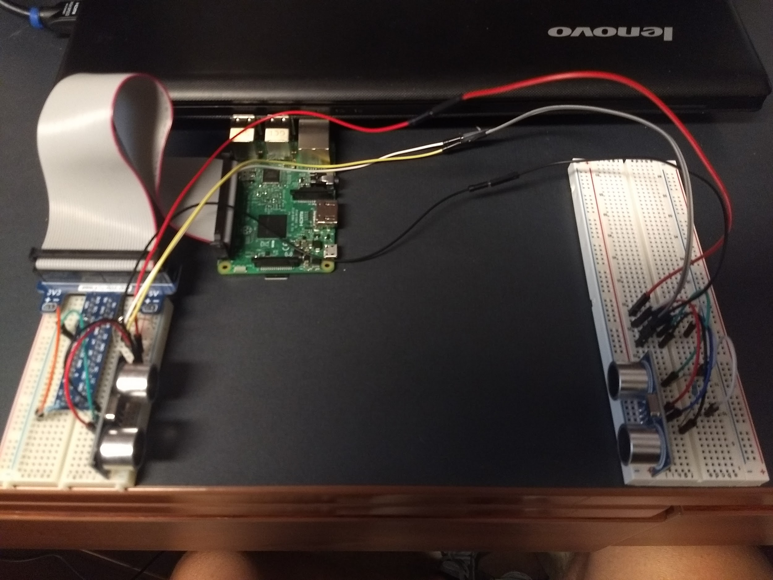Figure 1. Ultrasonic System

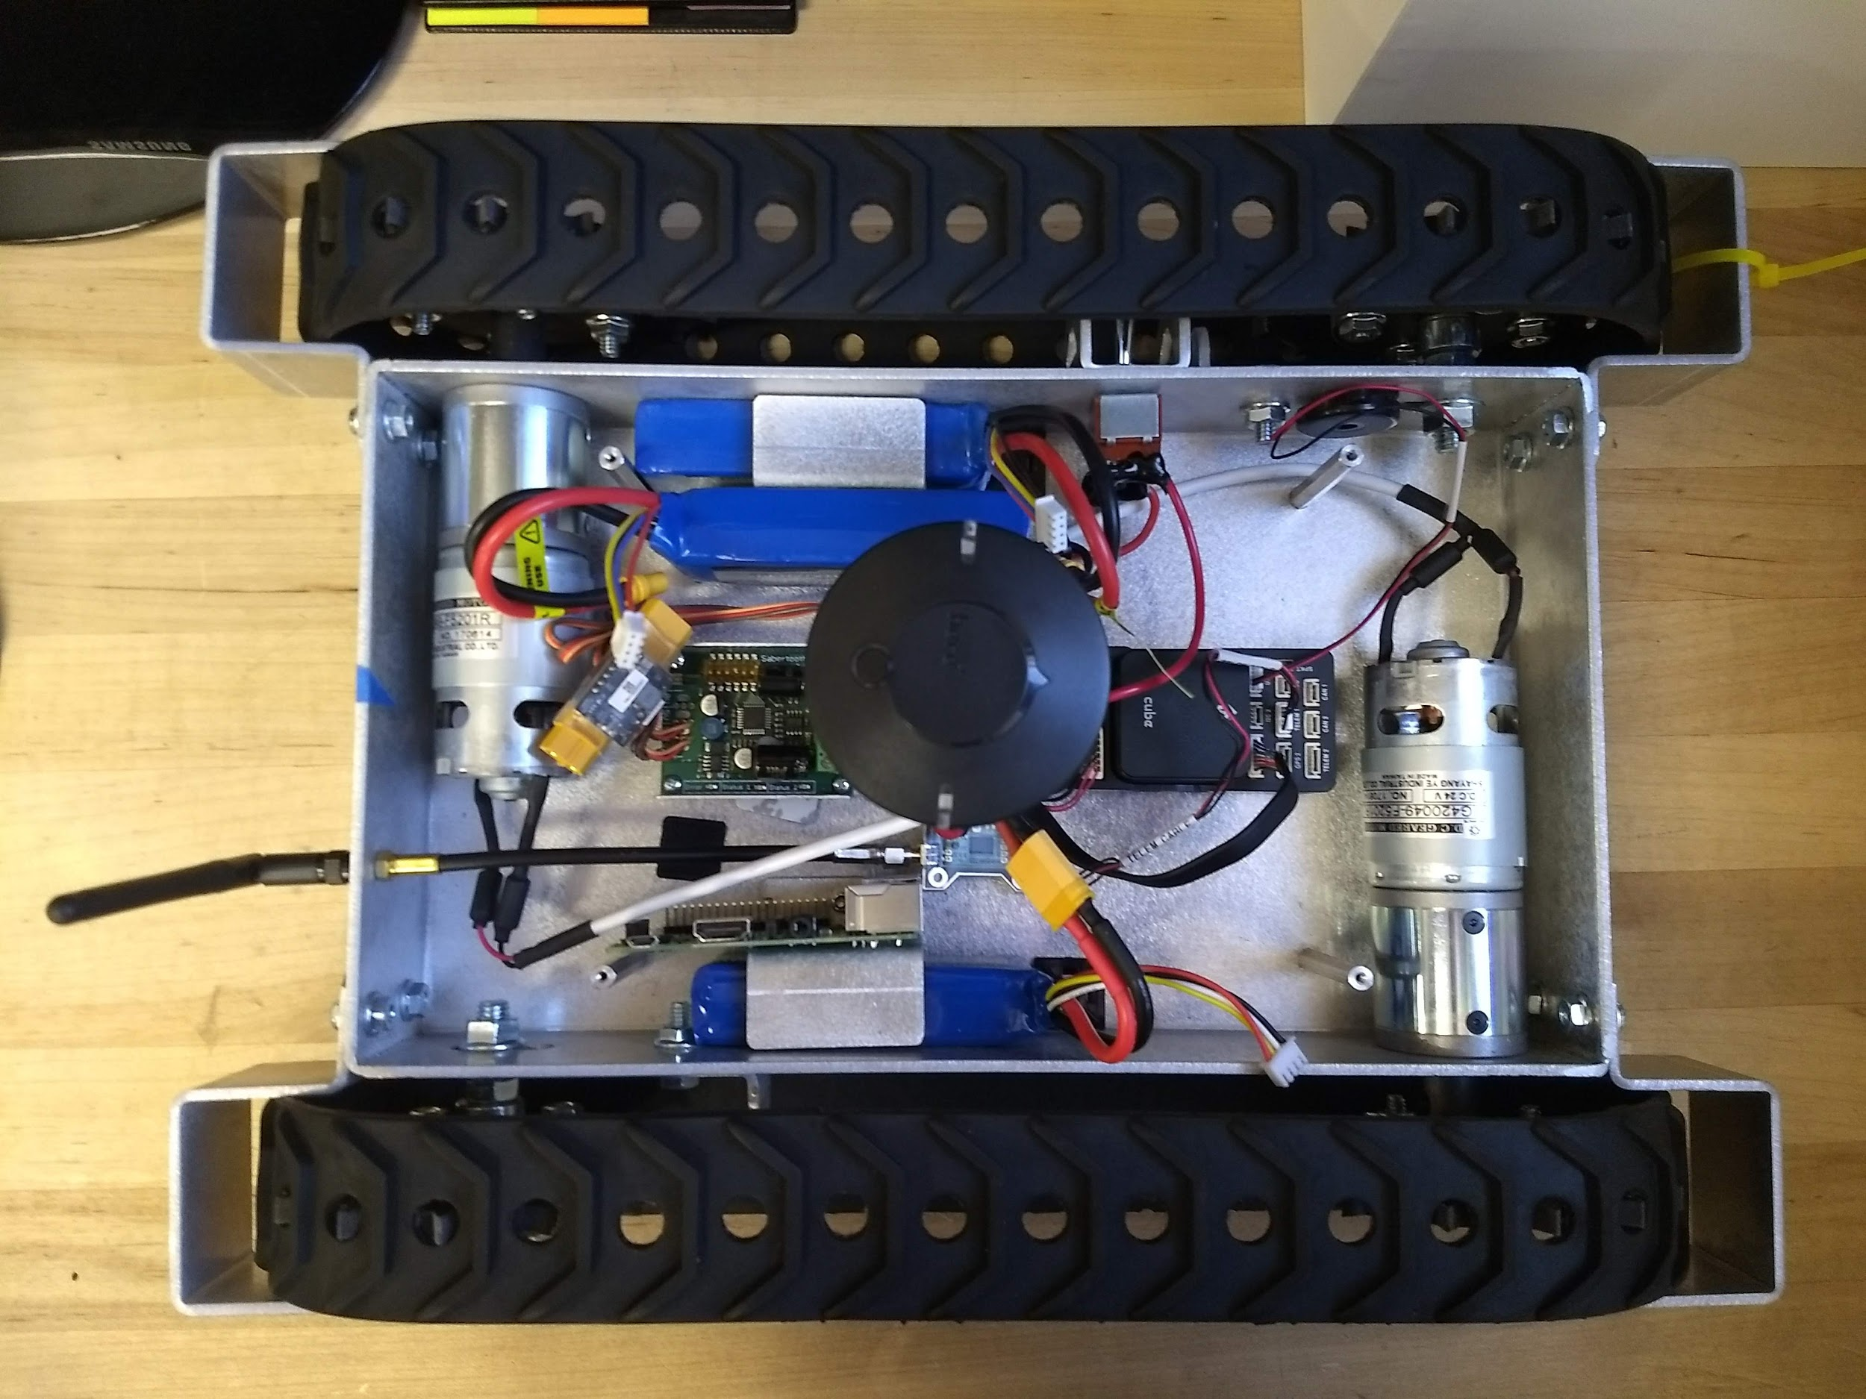

Figure 2.RPI, Pixhawk2.1, and Sabertooth2x12 with sensors.

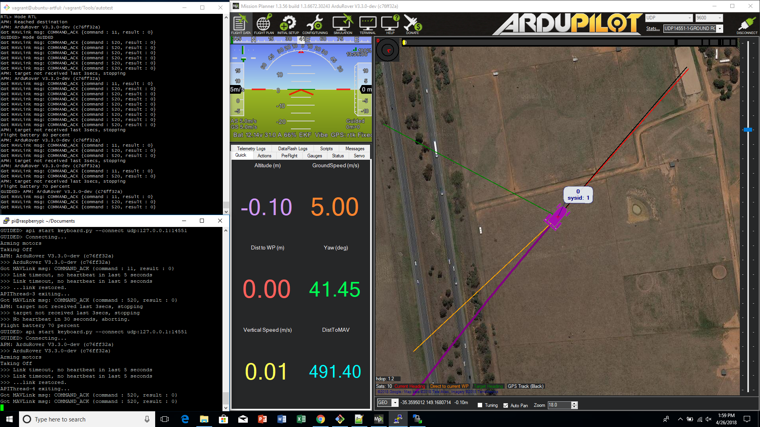

Figure 3. SITL simulation with MAVProxy operating over RPI SSH connection.

**2.1.3 Subsystem Conclusion**

Using the SITL simulator and allowing the ultrasonic system to simulate the WiFi base stations and MLA commands showed the vehicle subsystem is functioning properly. However, we encountered trouble with the motors moving forward in a straight line since the the motors on the rover had no hall sensors or encoders to allow for positional feedback. For future application, I recommend to write a program that capitalizes on the GPS module mounted on the rover to start navigation outdoors and then move to indoor navigation.

Autonomous RF Rover

Gabriel Wang

**RF Subsystem Report**

REVISION – Draft

December 5, 2018

**Table of Contents**

**Table of Contents.**

**3. Overview/Abstract 10**

**3.1 Development plan and execution 10**

3.1.1 Plan 10

3.1.2 Execution 10

3.1.3 Conclusion 12

**3. Overview**

The RF subsystem collects, filters, and sorts all useful data utilizing antennas, Tshark, python script, and the RP3. The subsystem was tested to validate that it could perform all the functions stated above in the ConOPs, ICD, and FSR.

**3.1 Development plan and execution**

**3.1.1 Plan**

For this subsystem, the main purpose was to be able to effectively collect RSSI signals so that the rest of the system can function. In order to do this the first step was to be able to get an antenna that would be able to collect 2.4 and 5.8 GHz signals. The second requirement was that the antenna had to be able to have monitor mode enabled so that the antenna would be able to read signal strength and IP address data without actually connecting to the source. In order to validate these 2 requirements, I had to first look up the specifications of the antennas, then interface it with our Kali Linux operating system in order to enable and test monitor mode. The two antennas that we ended up testing were the built in omnidirectional antenna built into the RP3, and a custom patch antenna given to us by Dr. Huff.

The next step was testing which antenna was able to collect the data most effectively. In order to do this, we first tested the omnidirectional antenna, the patch antenna in different configurations indoors and outdoors, and compared the data. This was an important step to ensure we would get the best results.

**3.1.2 Execution**

The ability to collect at least 5 data points was validated by running our python script that ran using Tshark. The script was programmed to collect 5000 packets and sort and save the IP address and RSSI signal. The program/antenna was able to collect these 5000 packets in just under 5 minutes. Figure 5/6 displays the graphed hallway position vs signal power of several wifi base stations. Figure 7/8 shows the data collected inside and outside with the omnidirectional antenna. Figure 9 shows the data collected inside with the patch antenna. These results clearly indicate why we chose the omnidirectional antenna. It was able to show solid differentiated data points, while the patch antenna often did not pick up signals.

The ability to access the RSSI signals and have monitor mode enabled was validated by running the python script and observing the data. The three antennas tested were able to enable monitor mode and collected the needed signals.

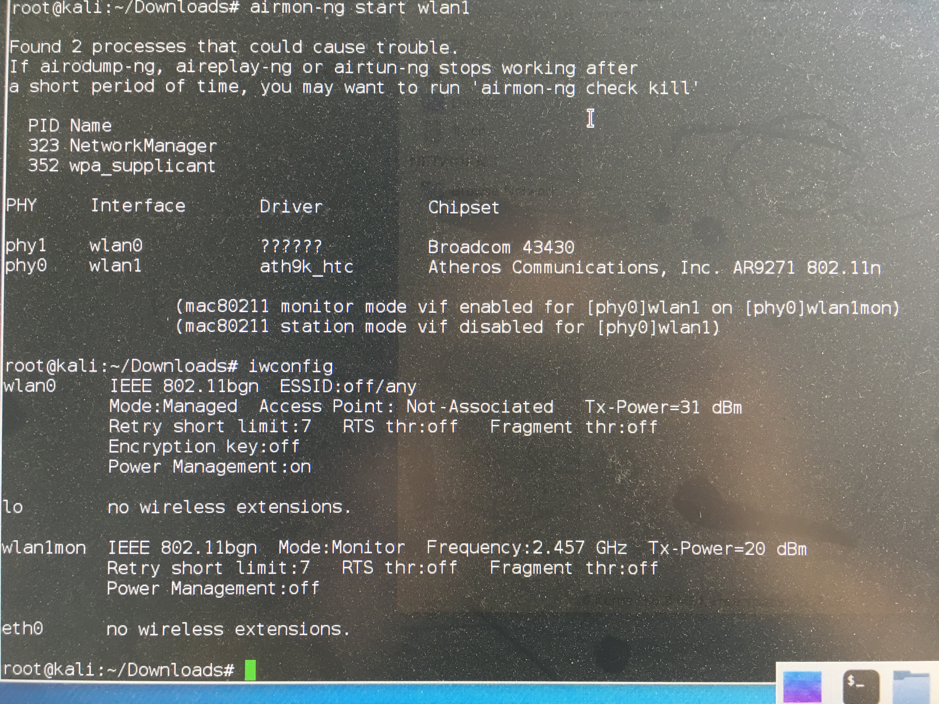

Figure 4: Screenshot of command prompt indicating working antennas

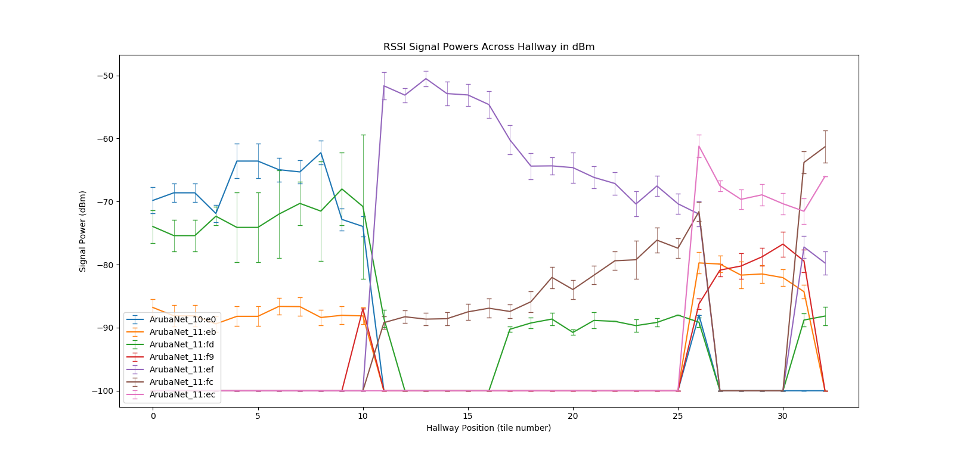

Figure 5: Hallway Position vs Signal Power of several Wifi Base Stations with MacBook Air Antenna

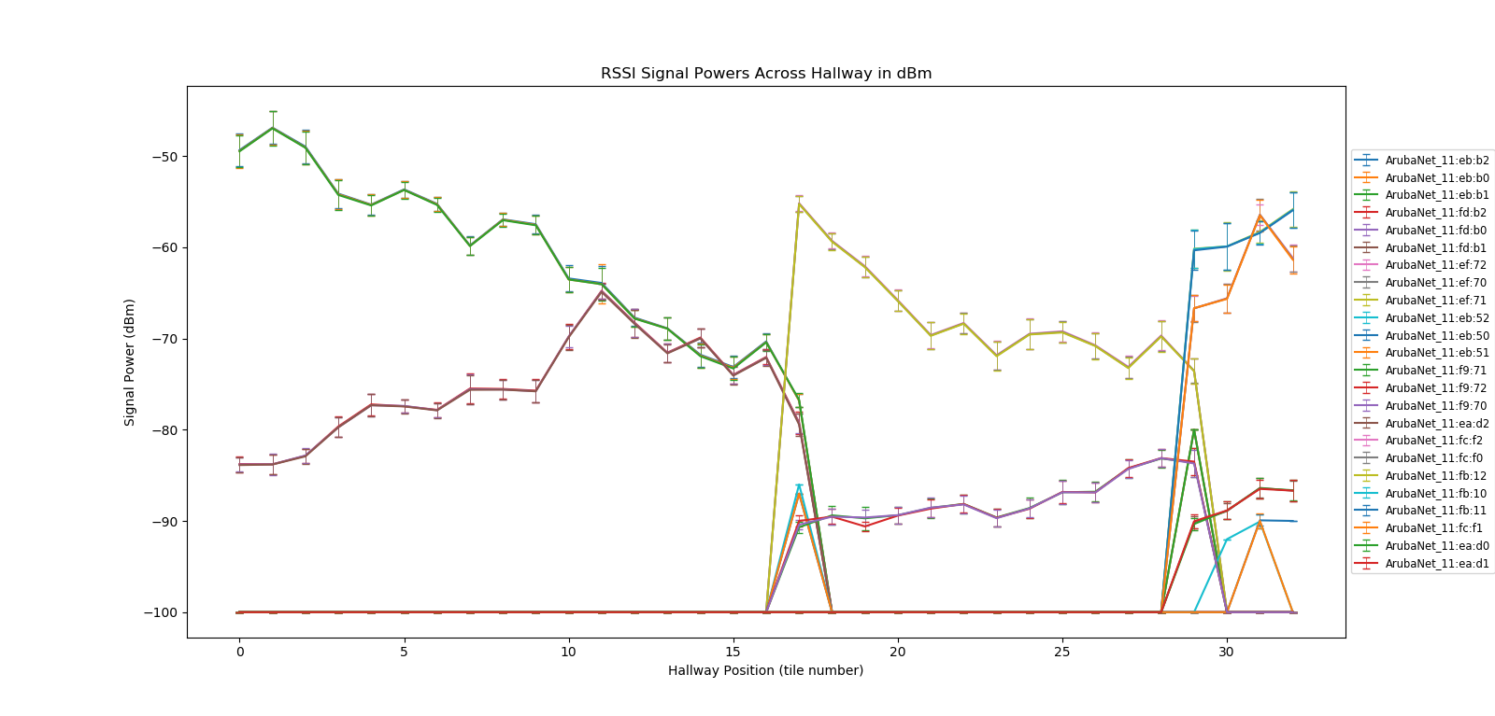

Figure 6: Hallway Position vs Signal Power of several Wifi Base Stations with RP3 Antenna

**3.1.3 Subsystem Conclusion**

There were many challenges with this subsystem that were not foreseen at the start of the project. The primary challenge was to be able to use an antenna to see RSSI data from the various wifi base stations. We quickly learned that the RP3’s antenna does not have monitor mode (a mode on the antenna that allows it to see data such as signal strength without connecting to the network) and so we were not able to collect useful data. Eventually we installed an operating system called Kali Linux that allowed us to install a patch and enable monitor mode. Another challenge was being able to autonomously collecting data. At first it was a manual process where we had to physically setup, start, save, and sort each time we collected data at a different point. This was very tedious as we had to collect data from 33 different locations inside WEB. We eventually managed to write a python script that was able to automatically do all the steps above with the push of one button saving a significant amount of time in future data collections.

The RF subsystem was able to accomplish everything we said it would do in our midterm report as well as more, as Dr. Huff and Dr. Chamberland continued giving more suggestions and tasks to meet once we hit our goals. Any useful wifi data in a building can be collected, the collection process is now automatic, and the subsystem is already merged with the database subsystem to almost instantly upload collected data to the SQL database to be accessed by the ML algorithm. Furthermore, we were able to make a data driven decision to use the omnidirectional antenna instead of the patch antenna for the final design. Finally, after learning that the base stations in WEB are commercial grade and use beamforming, we decided to switch to our own base station source (Feather Huzzah).

Looking forward, I would continue testing the omnidirectional antenna in even noisier environments to simulate a possible extreme case so that the final product would be able to still deliver. Furthermore, I would look into antennas that are commonly used in smartphones as a end use case could be to implement this algorithm into an app for the visually impaired.

Autonomous RF Rover

Skylar Dolezal

**Database Subsystem Report**

REVISION – Draft

December 5, 2018

**Table of Contents**

**Table of Contents.**

**4. Overview 15**

**4.1 Development plan and execution 15**

4.1.1 Plan 15

4.1.2 Execution 15

4.1.3 Tests 15

4.1.4 Conclusion 15

**4. Overview**

The Database Subsystem Report will explain the design process of the Database subsystem show the subsequent results. The Database Subsystem receives and manages the data collected by the RF Collection Subsystem. It then provides simple access of the data to the Algorithm for processing.

**4.1 Development Plan and Execution**

**4.1.1 Plan**

In order to use the least amount of memory on the data collection subsystem, I planned to establish a cloud based SQL database. This cloud based database was determined to store collected data and provide access of data to algorithm in a response time of less than one second via a internet connection. The data to be stored and accessed is the Address and RSSI information of collected Wifi Access Point network packets.

**4.1.2 Execution**

The data collected by rover is stored in a MySQL database hosted by the Google Cloud Platform. The data collected to be stored in database is transmitted by a Raspberry Pi 3 using a Proxy to give the quickest response time. The Raspberry Pi transmits the data through an installed Google Cloud SQL proxy using a Python program, more specifically using the PyMySQL module. The Python program inserts data into a MySQL database table and includes credentials to connect to the MySQL database.

The database gives accessibility of the data to the Algorithm via a separate Proxy, installed on computer hosting the Algorithm. Since Algorithm is written in Python, the same PyMySQL module is used for credentials and SQL data extraction.

The process to insert and retrieve data via proxy written in python was tested by inserting sample data into database, then retrieving data and determining total response time it took to accomplish. The following figure shows the results of the retrieved data and the total response it took, also showing the open and closed connection of MySQL instance through the proxy.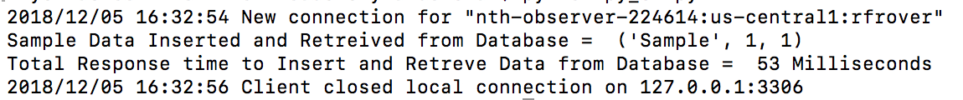

Figure 1: Response Time Test Results

As shown in Figure 1, the proxy was hosted on TCP port 3306 on the RPI and rfrover is the instance in the MySQL database being connected to for data collection.

**4.1.3 Conclusion**

The Database Subsystem successfully integrated with the RF and Algorithm Subsystem, storing collected data and making data accessible through a cloud based database. The average total response time of 50-55 ms was far quicker than required response time. The key decision made was to access MySQL database using a proxy and a local variable credential key that shorted response time by 400% versus the previous method of authorizing an IP address.

I would highly recommend using the Google API Cloud SQL service for anyone going forward with this project, both for research and commercial use. The ease of accessibility and authentication process makes data storage related to this project undemanding.

Autonomous RF Rover

Joseph DeLeonardis

**Machine Learning Subsystem Report**

REVISION – Draft

December 5, 2018

**Table of Contents**

**Table of Contents.**

**5. Overview 19**

**5.1 Development plan and execution 19**

5.1.1 Plan 19

5.1.2 Execution 19

5.1.3 Conclusion 21

**5. Machine Learning Subsystem Overview**

The purpose of the machine learning subsystem is accurately predict which relative position the rover is currently on by comparing the collected RSSI signal strength data of all the selected WIFI base stations in the area to a training dataset stored on the pi in the form of a CSV. This operation is critical for giving the rover the ability to predict which direction to go and if it has reached its destination.

**5.1. Development Plan and Execution**

**5.1.1 Plan**

A KNN algorithm was used to determine the pattern of the relative position and RSSI data. A categorical algorithm as opposed to linear regression because data was only collected at 10 linear points in an area. In this project we compared the data points to the 4 nearest neighbors from the training set.

**5.1.2 Execution**

This system was tested by placing four wifi base stations in an area to send signals to the rover. Upon importing the data the algorithm would assign it to be the testing set and compare it to a predefined training set that was stored on the RPI. This CSV was compared to the training set line by line to output the median predicted position so that the rover could make decisions based on this reference. A series of test were conducted prior to the final design to get an accuracy high enough to validate the design requirements, because the algorithm can not compute accuracy without having position defined in the testing. Upon running and compiling the code a testing error of 13% was recorded for the K nearest neighbors approach, achieving the specified engineering specification.

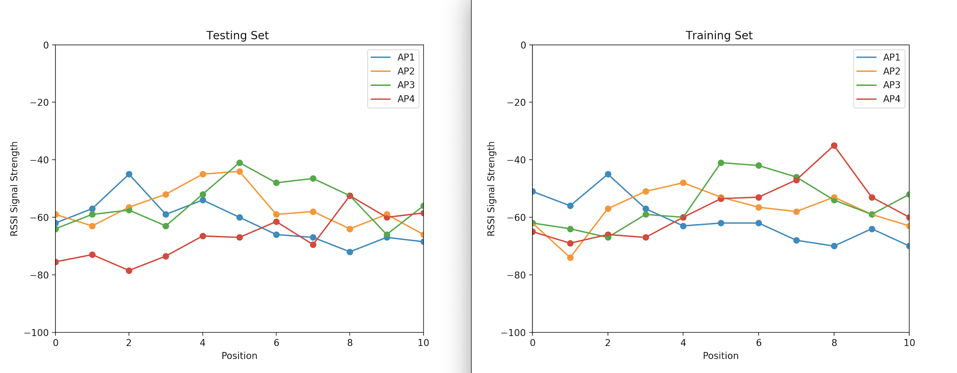

Figure 7: Inside Zachary Data Collection

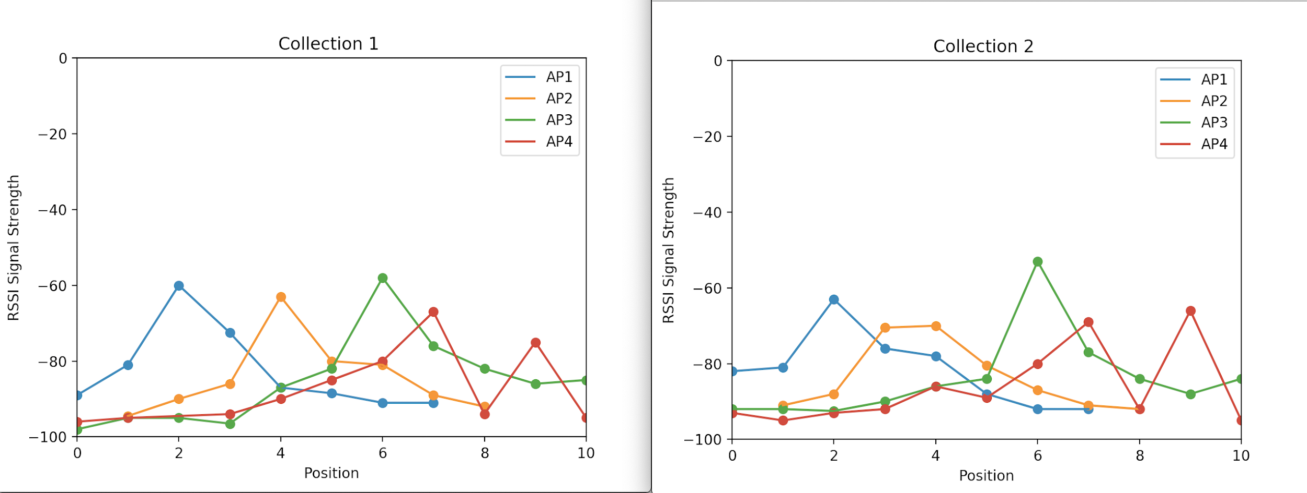

Figure 8: Outside in lot 50

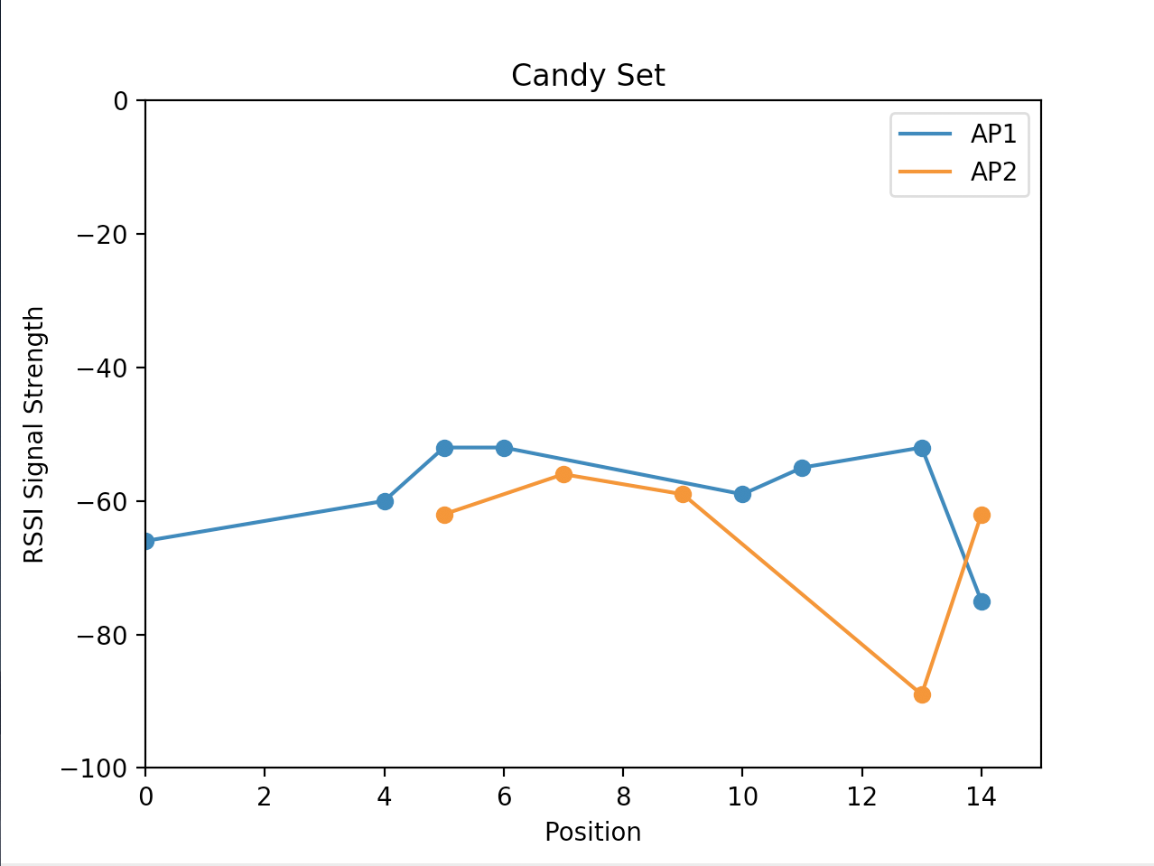

Figure 9: Initial Collection in Zachary

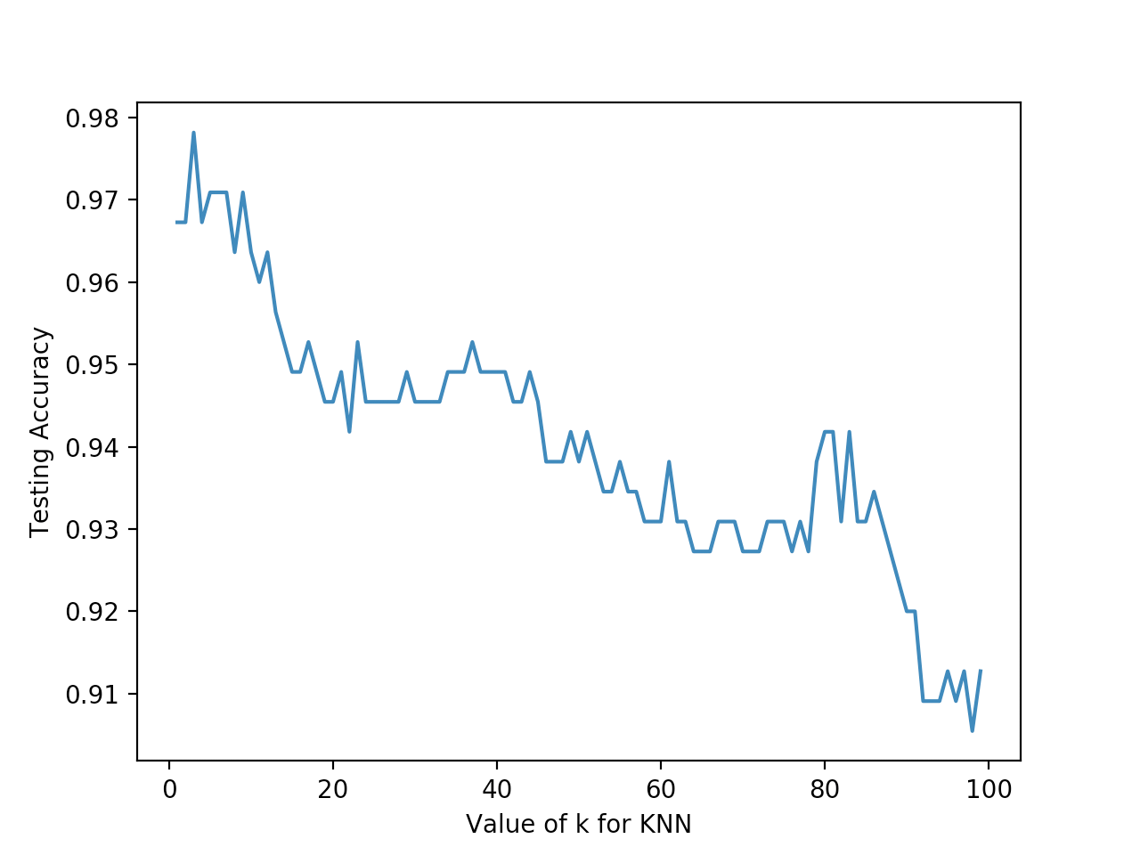

Figure 10: Train Test Split of a collected data set in Zach to verify accuracy with respect to K for how the data was structured in the final design

**5.1.3 Conclusion**

Testing and refining has been completed. The KNN algorithm has been placed inside a user defined algorithm that will import a predefined training set and then take in each relative position set as a testing set to compare with the training set. When the algorithm outputs a predicted position that is not equal to the final position the rover will move forward or backward and recursively call the algorithm again until it reaches the final position.

Autonomous RF Rover  
Jacob Pantalone

Gabriel Wang

Skylar Dolezal

Joseph DeLeonardis

**SYSTEM DESCRIPTION AND DEVELOPMENT  
(GROUP REPORT)**

REVISION – Draft

December 5, 2018

**Table of Contents**

**Table of Contents.**

**6. Overview 24**

**6.1 Development plan and execution 24**

6.1.1 Plan 24

6.1.2 Actual Data 24

6.1.3 Conclusion 25

**6. RF Rover System Report**

**6.1. Overview/ Abstract**

The RF rover will autonomously collect 2.4GHz/5GHz signals from Wifi Access Points as it moves along a straight path. The Rover will autonomously collect the signals network packets and determine the Address of the Wifi Access Point that transmitted the signal, as well as the RSSI of the signal. The collected data is then sent to a database to be evaluated by a Machine Learning Algorithm that will determine the Rover’s location based on previous collected training sets. The algorithm will communicate with the Rover it’s current location and based on this, the rover determines whether it has arrived at desired location and stop or keep moving to the desired location. The four subsystems that will work in unison to accomplish this is the Rover Vehicle Subsystem, the RF Collection Subsystem, the Database Subsystem, and the Machine Learning Algorithm Subsystem.

**6.2. Development Plan and Execution**

**6.1.1 Plan**

In order to test the entire system and see if it can correctly identify its location we needed to test it in an environment with little interference and as controlled of an environment as possible. To achieve this, we needed to test outdoors in a open area with nothing nearby to cause signal reflection or have any other signal sources. If this worked, we needed to test indoors in a controlled environment to see if the algorithm was able to handle all the added interference from bouncing signals and other RF signals. The way each environment was setup included four Feather Huzzah boards spaced 8 ft apart in a line outputting a 2.4 GHz signal. Then the rover was set up a to run parallel to the boards and collect and stop on this parallel line. When the program started, the antenna would collect and filter the RSSI signals from each Feather Huzzah board, store it, move forwards 6 ft and continue this process ten times. The rover would then go back to the beginning and begin collecting data again. Using this data, it would compare it to the original data taken in the first collection set in order to identify which point it is at. From here it would either move forwards or backwards until it reached the assigned location.

**6.1.2 Execution**

The validation of the RF Rover system consisted of an indoor trial inside one of the hallways of the Zachary building and an outdoor trial on a sidewalk near the Emerging Technologies Building. While the subsystem worked for both the indoor and outdoor trials with target position 5, only the outdoor scenario consistently arrived at its target position using any value. As seen in Figure 10, the MLA returned an array of a lot of different guesses at the rover’s current position. The first 3 positions are supposed to be position 2, 3, 4 respectively but all are predicted to be position 3 from the MLA. This indoor trial shows how RF interference from other base stations and signals bouncing around can affect the accuracy of the MLA. In Figure 11, the rover started ahead of the target position and moved backwards. The actual positions of the rover are 8, 7, 6, then 5. In this case, the MLA successfully outputs a very accurate array of predicted position 8, 7, 6, 5 respectively.

**6.1.3 Conclusion**

Our final demo was able to show that each subsystem was able to work collectively together in order to accomplish the end goal of correctly identifying its location using RSSI data. The RF subsystem was able to successfully collect and filter data and send it to the database subsystem, which was then able to be accessed and ran by the machine learning algorithm, which finally was able to send a command to the rover to either move forwards, backwards, or stay as it is in the correct location. We were able to prove that an RF wifi system is able to correctly identify its location in low noise environments (outdoors), and also inside noisy environments (building hallway) with a non beamforming source

Looking forwards, we could further explore different environments (hallway with people walking around, etc) and even turn the system into a mobile phone application. Furthermore, we could look into solving the beamforming problem, possibly by taking in huge amounts of data and running it through a machine learning algorithm.

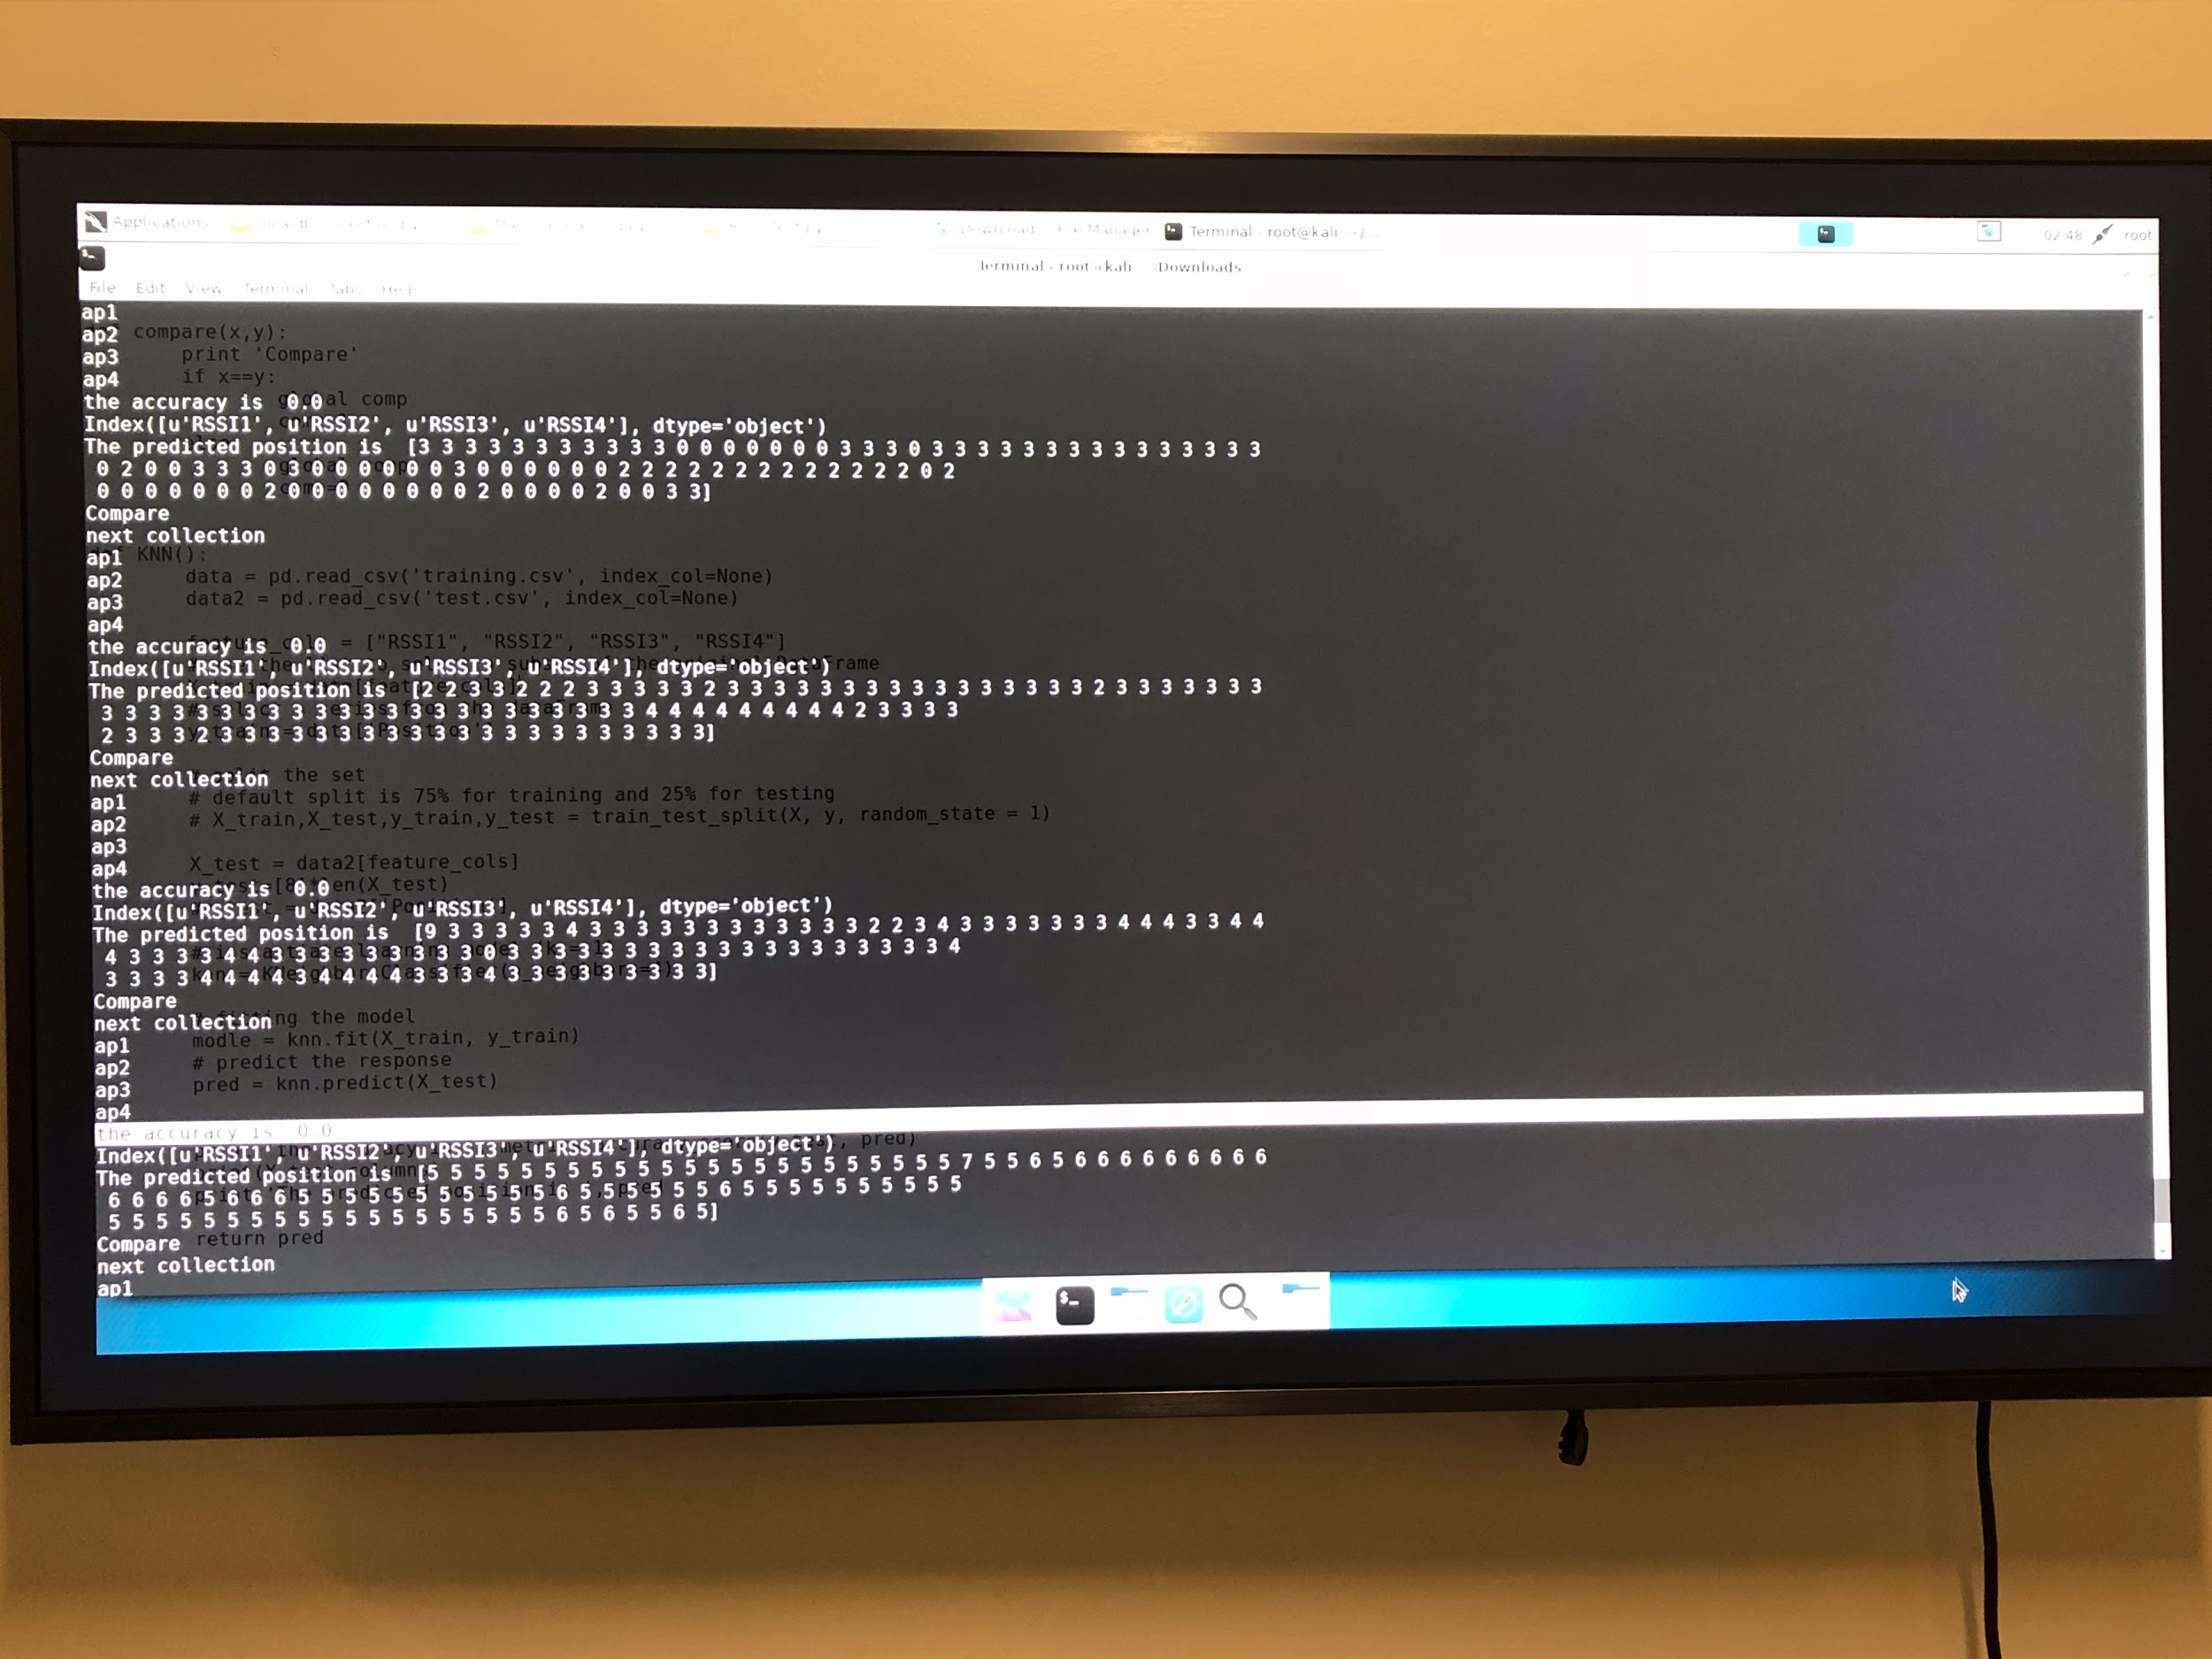

Figure 11: Indoor Validation Results (Target Position = 5)

Figure 12: Outdoor Validation Results (Target position = 5)